1. INTRODUCTION

Graphics provides one of the most natural means of communicating with a computer, since our highly developed 2D and 3D pattern-recognition abilities allow us to perceive and process pictorial data rapily and efficiently. Interactive computer graphics is the most important means of producing pictures since the invention of photography and television. It has the added advantage that, with the computer, we can make pictures not only of concrete real world objects but also of abstract, synthetic objects, such as mathematical surfaces and of data that have no inherent geometry,such as survey results.
We have designed an animation depicting the Car Stunt. The design incorporates some of the concepts that we have learnt in Computer Graphics theory. The scene consists of a bridge like set up meant for the stunt and the audience. Depending on the speed input by the user using the menu interface car performs the stunt and if the speed input is within the safe landing range car lands safely on the other side of bridge without any damage. If the speed input is not within the range meant for safe landing the car crashes onto the bridge damaging the bridge and car undergoes heavy damage.
In the subsequent sections we will discuss in detail the features of this and the methods behind implementing them.
- REQUIREMENT ANALYSIS
Software Requirements:
- An operating system like Windows 2000, Windows XP or Windows Vista is the platform required to develop and execute the animated simulation.
- A compiler like Microsoft Visual C++, Version 6.0 or above (integrated with OpenGl), is required for compiling the source code to make the executable file.
- A graphics library (glut.h) including all the other required header files is necessary to build the project.
- glut32.dll for running the application.

Hardware Requirements:
The hardware requirements are very minimal and the software can run on most of the machines.
- Processor - Intel 486/Pentium processor or above.

Processor Speed - 500 MHz or above

RAM - 64MB or above

Storage Space - 2 MB or above

- Monitor resolution - A color monitor with a minimum resolution of 640*480.

3. DESIGN AND IMPLEMENTATION
This graphics animation is designed and implemented using OpenGL
with C/C++ programming language.We have used Microsoft Visual C++
for the same. The various functions available in the graphics library
glut.h have been used to implement the animation.
We have used many inbuilt functions and user-defined functions for
our project.So various functions used are discussed below.
User Defined Functions:
- void cartop( int x , int y , int z , GLfloat length , GLfloat breadth , GLfloat height , GLenum mode);
- void carbase( int x , int y , int z , GLfloat length , GLfloat breadth , GLfloat height , GLenum mode);
- void window();
- void drawwheel();
- void drawexst();
- void drawbulb();
- void drawBridge();
- void stadium();
- void man();
- int main();
- void idle();
- void Mymenu();
- void speed();
- void myRe();
- void Dis();
Now lets see in detail each of the above functions:
void cartop( int x , int y , int z , GLfloat length , GLfloat breadth , GLfloat height , GLenum mode):
This function is used to draw the top portion of the car used for the stunt.Interpolation is used for getting gradient colouring.
void carbase( int x , int y , int z , GLfloat length , GLfloat breadth , GLfloat height , GLenum mode):
This function is used to draw the bottom portion of the car used for the stunt.It draws a cuboid using openGL inbuilt functions.
void window():
This function is Used to draw the four windows of the car.This is also used to draw the wind screen of the car.
void drawwheel():
This function is used to draw four wheels of the car with proper alignment. OpenGL inbuilt function GluDisk() with appropriate parameters are used to get the wheel with rotations applied and transformed to four positions of the car below car base using transformation functions.
void drawexst():
This function is used to draw the exhaust pipe of the car.GluCylinder function of OpenGL library is used along with rotation and transformation.

void drawbulb():
This function is used to draw bulbs for the car at the front as well as back.OpenGL function GlutSolidSphere is used.
void drawBridge():
This function is used to draw the bridge like set up meant for performing stunt. OpenGL function rectf() is used. The pillars for the bridge are also drawn. The structure consists of a slanted bridge followed by an attached straight bridge and then gap of few distance again followed by bridges.
void stadium():
This function is used to get a stadium like structure for the stunt area.
void man():
This function is used to draw the audience.Various OpenGL inbuilt functions are used.
int main(int argc,char** argv)
This function does the following:
- Sets the name of the display window.
- Enables full screen viewing.
- Creates a menu which is displayed on clicking the right mouse button.
- Calls display callback function.
- Calls reshape callback function.
- Calls idle callback function.
- This calls the event loop as well.
void idle():
This idle call back function called by glutIdleFunction when there is no event happening. We have used this function as the basis for animation using OpenGL transformation, rotation and scaling function using appropriate variables and flags.
void Mymenu():
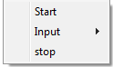
This function is used to form the main menu on the main screen using OpenGL inbuilt functions.
void speed():
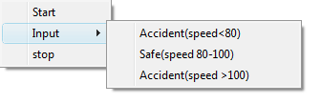
This function is used for creating submenu of the main menu and is used to input various speeds by the user.
void myRe():
This is registered as reshape callback function. This function is called when the program is first run and whenever there is a reshape event occurring. The required perspective view and the viewport is set up in this function.
void Dis():
This is the display callback function.All the functions required to draw the scene are called here. Whenever there is a request for the display of the scene this function is called.

The various OpenGl library functions used are discussed here:
void glVertex3f (GLfloat x, GLfloat y, GLfloat z);
Function to specify the position of the vertex.

Void glBegin (GLenum mode);
Function to initiate a new primitive.

Void glEnd(void);
Function to terminate a list of vertices.

void glColor3f (GLfloat red, GLfloat green, GLfloat blue);
void glColor3ub (GLubyte red, GLubyte green, GLubyte blue);
Function to set the RGB (or RGBA) colors.

Void glClearColor (GLclampf red, GLclampf green, GLclampf blue, GLclampf alpha);
Function to set the color when clearing the color buffer.

void glFlush(void);
Function to execute any buffered OpenGl command to execute.

glutCreateWindow(“Simulation of car Stunt”);
Function to create a display window.

glutInitDisplayMode(GLUT_DEPTH|GLUT_RGBA|GLUT_DOUBLE);
Function to set the properties of the display mode.

glutInitWindowSize(700,700);
Function to set the window height and width in pixels.

glViewport(0,0,w,h);
Function to set the viewport.

glutMainLoop();
Function to cause the program to enter an event processing loop.

glutDisplayFunc(dis);
Function which registers the dis callback function.

glutPostRedisplay();
Function to request the display callback after the current callback returns.

glutSwapBuffers();
Function to swap the front and back buffers.

glutReshapeFunc(myRe);
Function which registers the myRe callback function.

glutIdleFunc(idle);
Function which registers the display callback function idle that is executed when no other event is being handled.

glutCreateMenu(mymenu);
Function to create a menu.

glutAddMenuEntry(“Start”,1);
Function to add a menu entry in the current menu.

glutAttachMenu(GLUT_RIGHT_BUTTON);
Function to attach the menu to the specified mouse button.

glEnable(GL_DEPTH_TEST);
Function to enable depth testing.

glDisable(GL_DEPTH_TEST);
Function to disable depth testing.

void glMatrixMode (GLenum mode);
Function to specify which matrix will be affected by subsequent transformations.
void glLoadIdentity(GLenum mode);
Function to set current transformation matrix to an identity matrix.

void glPushMatrix(void);
Function to push the content of the matrix stack corresponding to the current matrix mode

void glPopMatrix(void);
Function to pop the content of the matrix stack from the current matrix mode

void glTranslatef (GLfloat x, GLfloat y, GLfloat z);
Function which translates the current matrix.

Void glScalef (GLfloat x, GLfloat y, GLfloat z);
Function which scales the current matrix.

void glRotatef (GLfloat angle, GLfloat x, GLfloat y, GLfloat z);
Function which rotates the current matrix.

gluPerspective(165,(GLfloat)w/(GLfloat)h,20,100);
Function to specify the perspective viewing volume.

glRasterPos2f(x, y);
Function to specify raster position

glClear(GL_COLOR_BUFFER_BIT);
Function to clear the color buffer

glutBitmapCharacter(font, string[i]);
Function to render the character at a specified raster position using a given font.

glRectf(x1,y1,x2,y2);
Function to draw the rectangle.
void gluCylinder (
GLUquadric *qobj,
GLdouble baseRadius,
GLdouble topRadius,
GLdouble height,
GLint slices,
GLint stacks);
Function to draw a cylinder.

void gluDisk (
GLUquadric *qobj,
GLdouble innerRadius,
GLdouble outerRadius,
GLint slices,
GLint loops);
Function to draw cylindrical disk.

void glutSolidSphere(GLdouble radius, GLint slices, GLint stacks);
Function used to draw solid sphere.
SNAPSHOTS
1.Title page of CAR STUNT
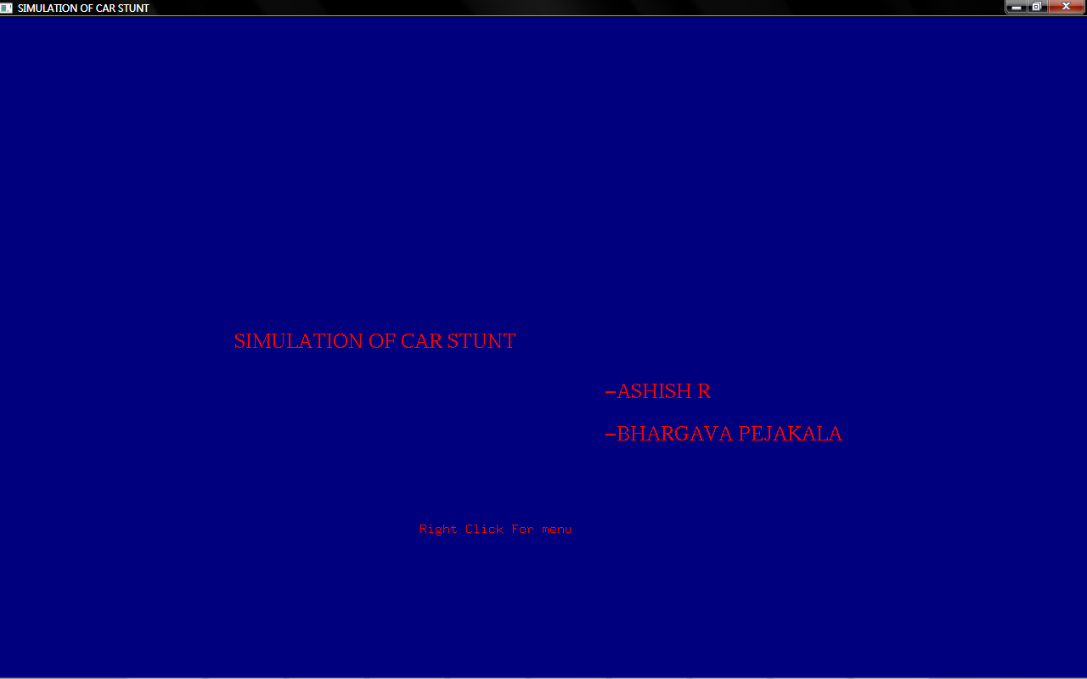
2.Initial Scene.
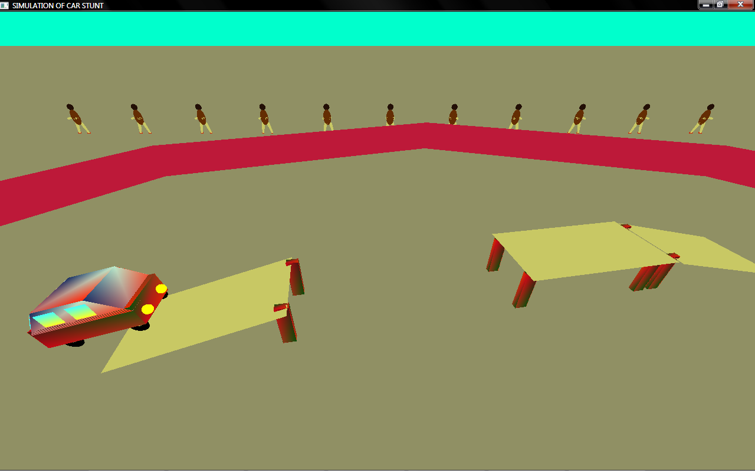
3.Menu Display.
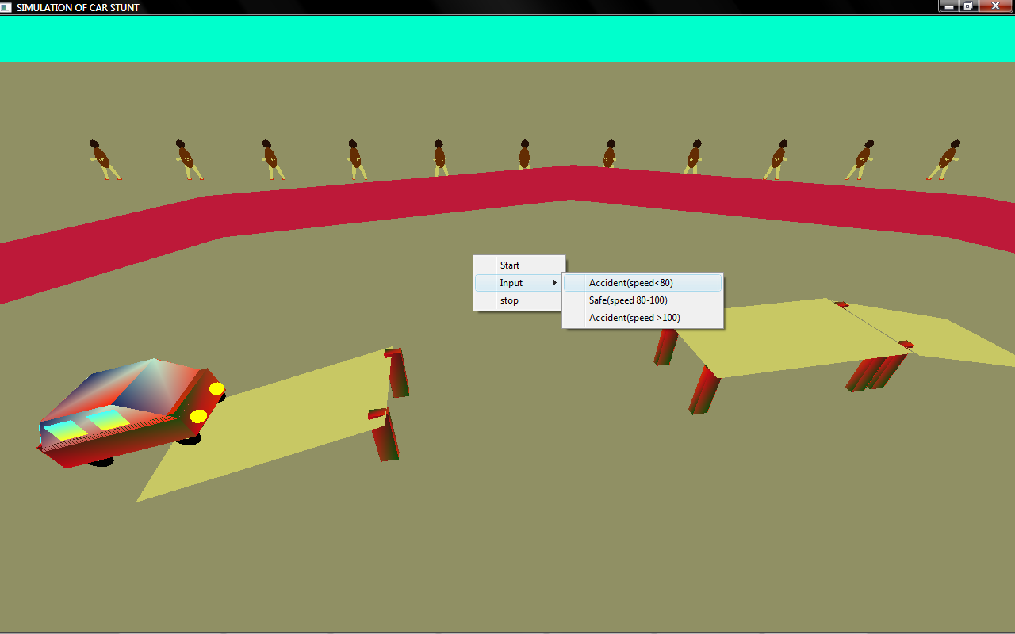
3.Car In motion.
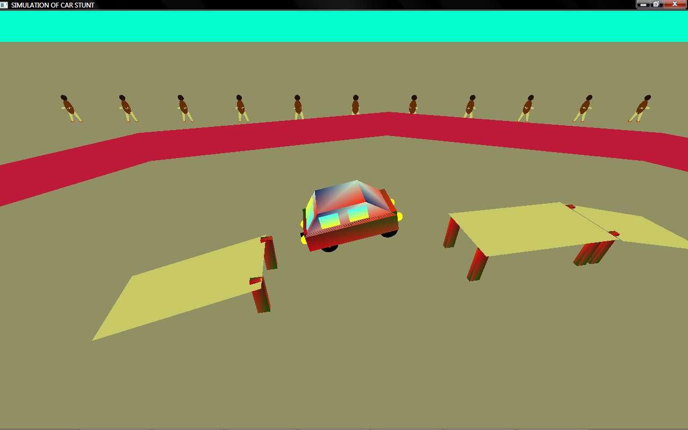
4.Successful Landing.
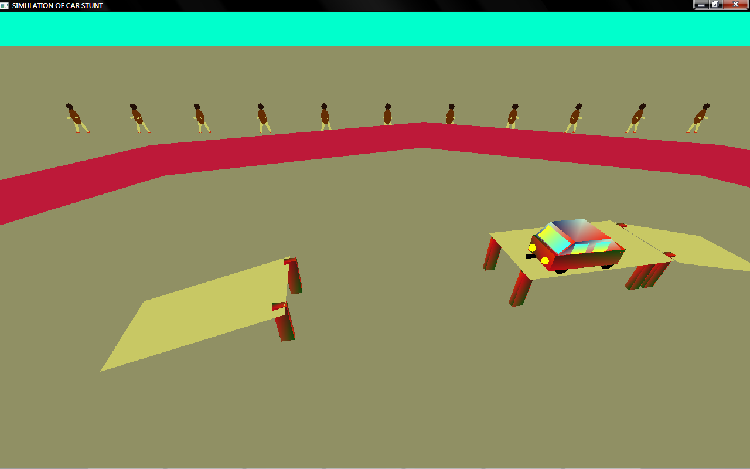
4.Car Getting Toppled before crash.
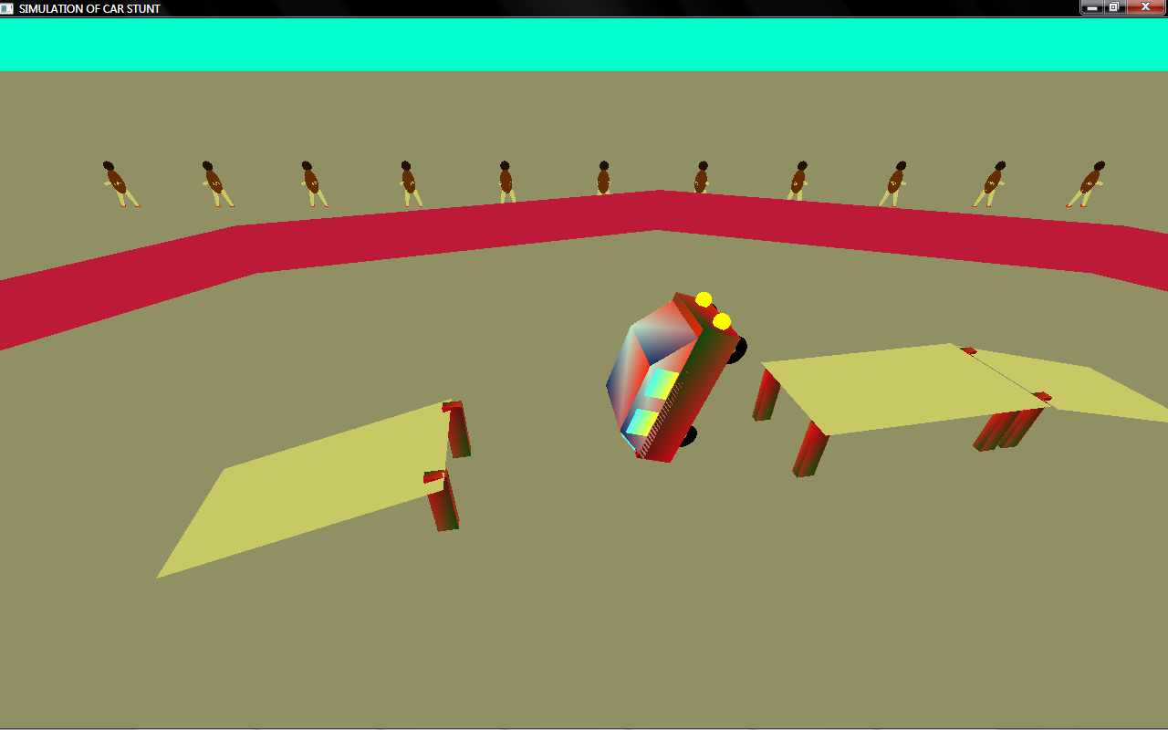
5.After the crash.
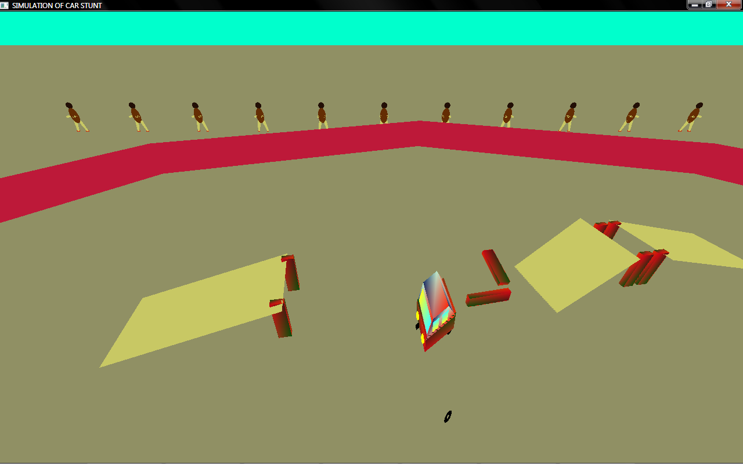

CONCLUSION

We have developed a graphics package to implement the skills learnt in theory using OpenGL in accordance to VTU specifications. The animation we have designed consists of various aspects of Computer Graphics and Visualization that are included in our syllabus for this subject. We have used the primitive concepts of points, lines and polygons to draw the various objects.Various transformation functions like translation,rotation and scaling are used to get the desired effects.We have done our level best and come up with our earnest efforts.

FUTURE ENHANCEMENTS

- More realistic effect.
- Inclusion of lighting and shading.
- Having many models of the car and giving the user the option to choose one.
- Including sound effects for motion and crashing of the car.
- Add more objects into the scenery like clouds, trees, vehicles, human figures etc.

BIBLIOGRAPHY

- Interactive Computer Graphics 5th Edition- Edward Angel
- OpenGL Programming Guide 6th Edition- OpenGL Architecture Review Board
- OpenGL SuperBible 4th Edition- Richard S. Wright Jr. , Benjamin Lipchak, Nicholas Haemel
- OpenGL Graphics Through Applications- Robert Whitrow

